Name: | David Daniels
UID: | 2023300038
Experiment No. | 1

AIM: | Program on Encapsulation: Write a program to demonstrate classes and objects
Program 1
PROBLEM STATEMENT : | Write a program using classes and objects to print all even and odd numbers in the range of 1-100 as well as the total number of even and odd numbers in the given range.  As an extra, the range may be inputted from the user.  Use the concept of classes and objects.
PROGRAM: | import java.util.*;  class check {  void check_no(int start, int end)  {  int even=0;  int odd=0;  System.out.println("Even numbers are: ");  for(int i=start; i<=end ; i++)  {  if (i%2==0)  {  System.out.printf("%d ",i);  even++;  }  }  System.out.println("\n\nOdd numbers are: ");  for(int i=start ; i<=end ; i++)  {  if (i%2!=0)  {  System.out.printf("%d ",i);  odd++;  }  }  System.out.printf("\n\n there are %d even numbers and %d odd numbers ",even,odd);  }  }  public class eve_odd {  public static void main(String[] args) {  Scanner sc = new Scanner(System.in);  System.out.println("enter start range: ");  int start = sc.nextInt();  System.out.println("enter end range: ");  int end = sc.nextInt();  check num = new check();  num.check_no(start,end);  sc.close();  }  }
RESULT: 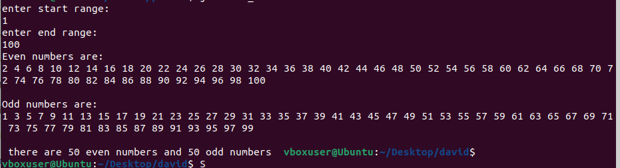
Program 2
PROBLEM STATEMENT : | Write a program to find all prime numbers in the given range. Print the prime numbers and total number of prime numbers in the range. Use the concept of class and objects.
PROGRAM: | import java.util.*;  class prime_check  {  void check_prime(int start, int end)  {  System.out.println("\n\nprime numbers are: ");  int prime =0;  int flag =0;  for(int i=start ; i<=end ; i++)  {  flag=0;  if(i==2 || i==1)  {  System.out.printf("%d ",i);  prime++;  }  else  {  for(int j=2;j<=i/2;j++)  {  if(i%j==0)  {  flag=1;  break;  }  }  if(flag==0)  {  System.out.printf("%d ",i);  prime++;  }  }  }  System.out.printf("\n\n there are %d prime numbers",prime);  }  }  public class prime  {  public static void main(String[] args)  {  Scanner sc = new Scanner(System.in);  System.out.println("enter start range: ");  int start = sc.nextInt();  System.out.println("enter end range: ");  int end = sc.nextInt();  prime_check num = new prime_check();  num.check_prime(start,end);  sc.close();  }  }
RESULT: 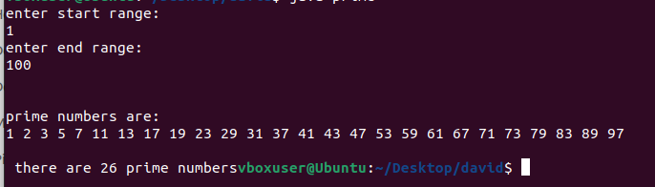
Program 3
PROBLEM STATEMENT: | Write a program to print all Armstrong numbers in the range inputted by the user. Also print the total count of Armstrong numbers in the range.  Use the concept of classes and objects.
PROGRAM: | import java.util.*;  class arm_check  {  void check_arm(int start, int end)  {  int arm=0;  System.out.println("\n\narmstrong numbers are: ");  for(int i=start ; i<=end ; i++)  {  int digi_no=0;  int temp=0;  int sum=0;  int rem=0;  temp =i;  while(temp>0)  {  temp=temp/10;  digi_no++;  }  temp=i;  while(temp>0)  {  rem= temp%10;  sum+= Math.pow(rem,digi_no);  temp= temp/10;  }  if (i==sum)  {  System.out.printf("%d ",i);  arm++;  }  }  System.out.printf("\n\n there are %d armstrong numbers ",arm);  }  }  public class armstrong {  public static void main(String[] args) {  Scanner sc = new Scanner(System.in);  System.out.println("enter start range: ");  int start = sc.nextInt();  System.out.println("enter end range: ");  int end = sc.nextInt();  arm_check num = new arm_check();  num.check_arm(start,end);  sc.close();  }  }
RESULT: 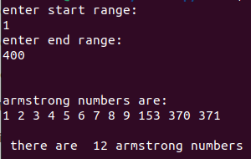
Program 4
PROBLEM STATEMENT:
PROGRAM:
RESULT:
CONCLUSION: | Thus, we have learned how to use classes to encapsulate code and make it more secure by using constructors which is passing arguments to a class file which can contain private or protected variables only accessible through methods. Thus security of a program written using encapsulation is much more than one using a structured programming approach

